8/5/2021

Umar Ali

**2K18/IT/26**

**Network Management and Security**

Assignment 2

* **Constructed the Internetwork of 4 LANs using four routers**.

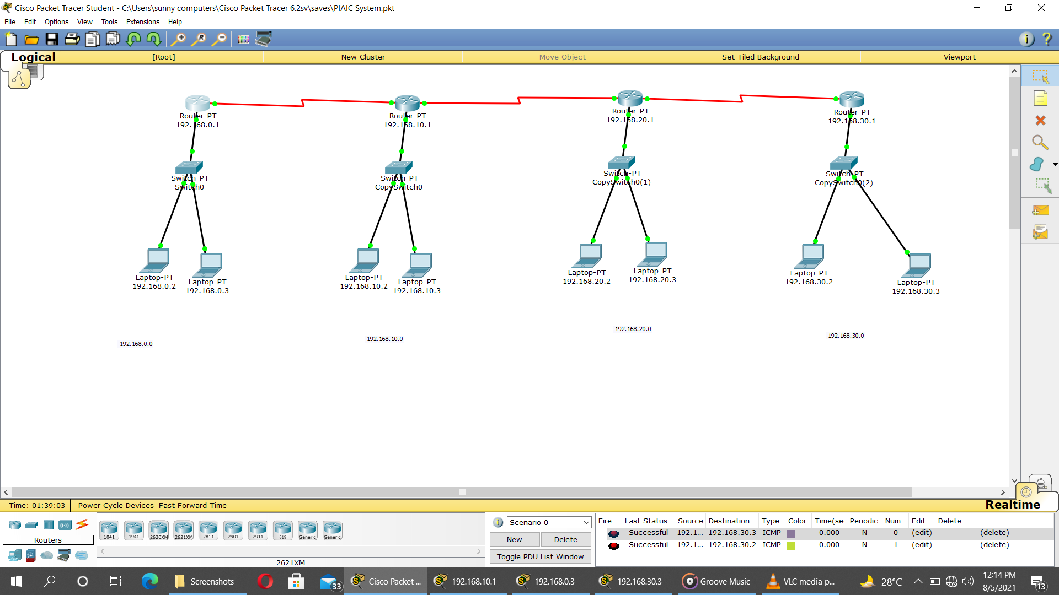

* 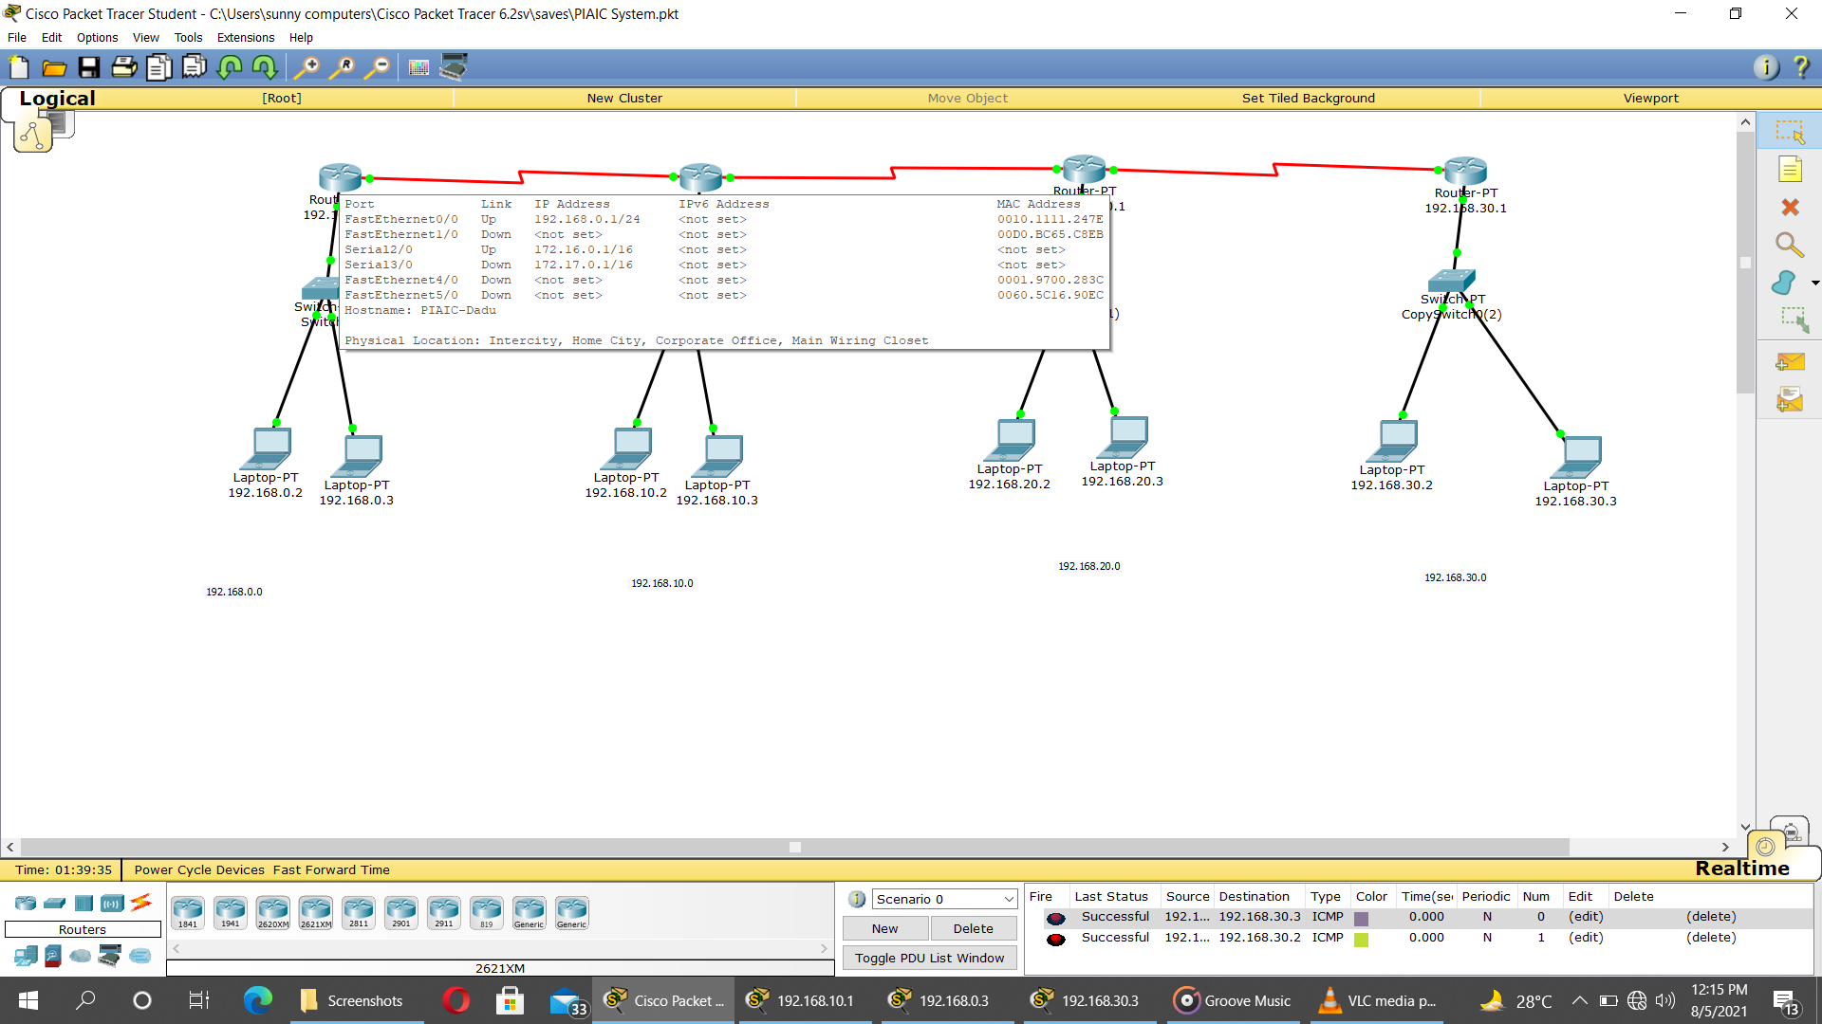**Configure RIP protocol for the networks using CLI mode of the router, And View routing table of various routers.**

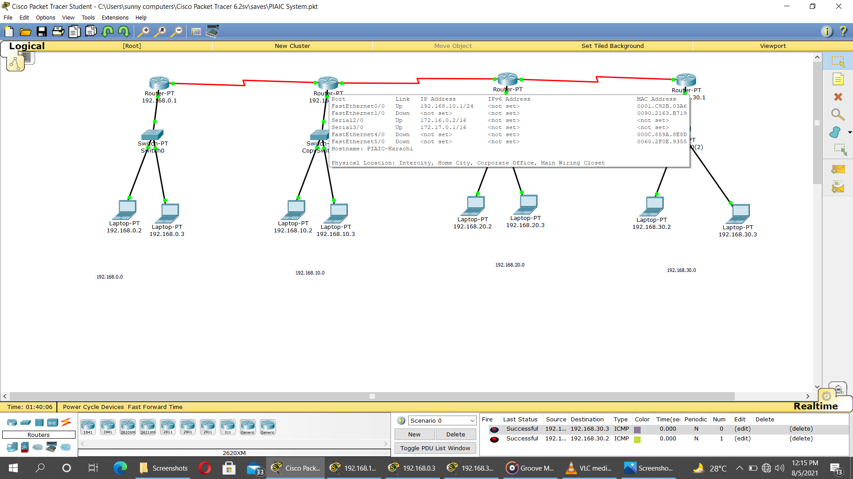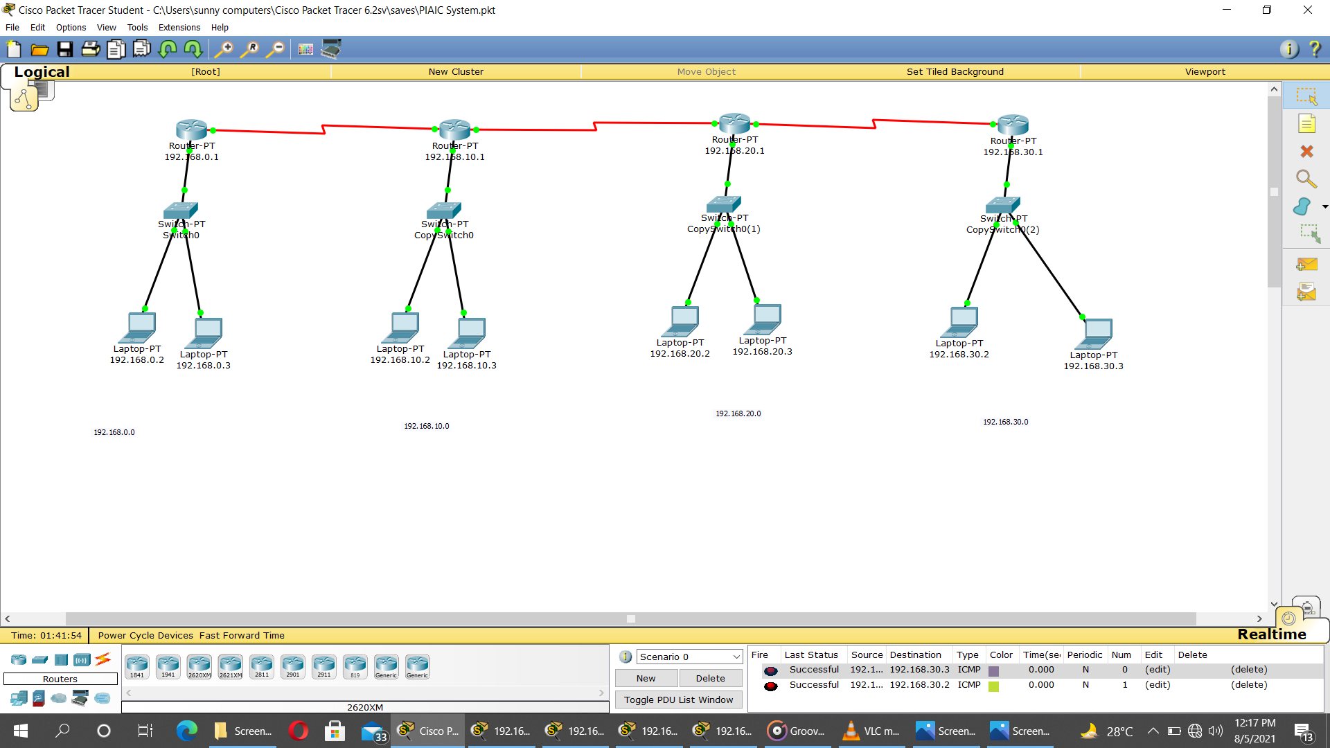

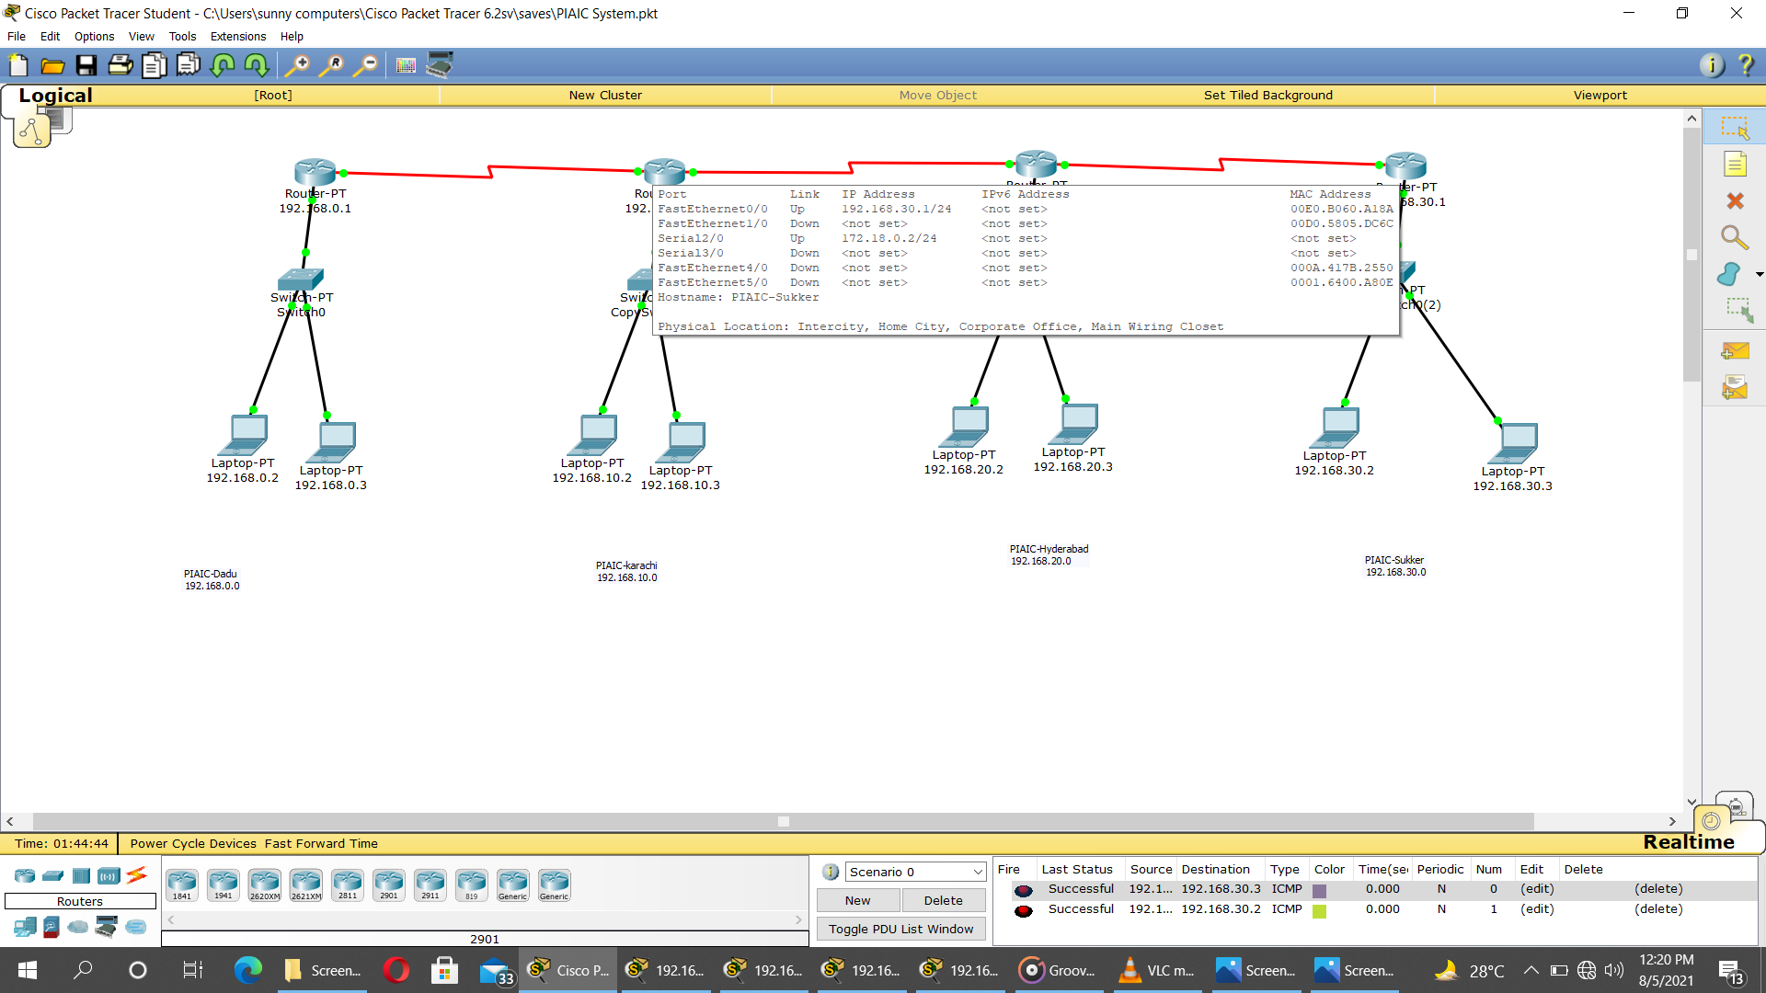

**Using Below command I Block Telnet . Telnet is blocked but that network can not be accessible with that network which has I given permission**

* **to deny access list**

**access-list 100 deny tcp any any**

* **to permit**

**#access-list 100 deny tcp any any**

**#access-list 100 permit tcp host 192.168.30.2 eq telnet host 192.168.0.1**

**access-class 100 in**

* 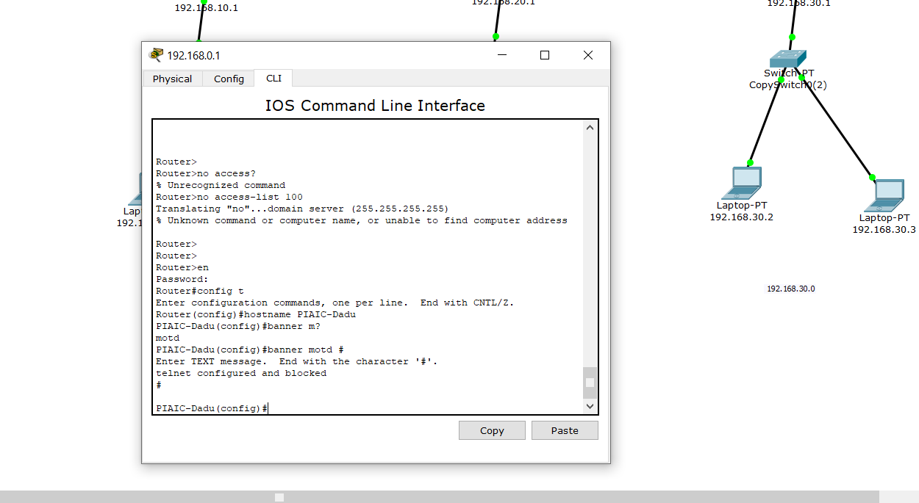**using cli change host name banner of blocked telnet network.**
* 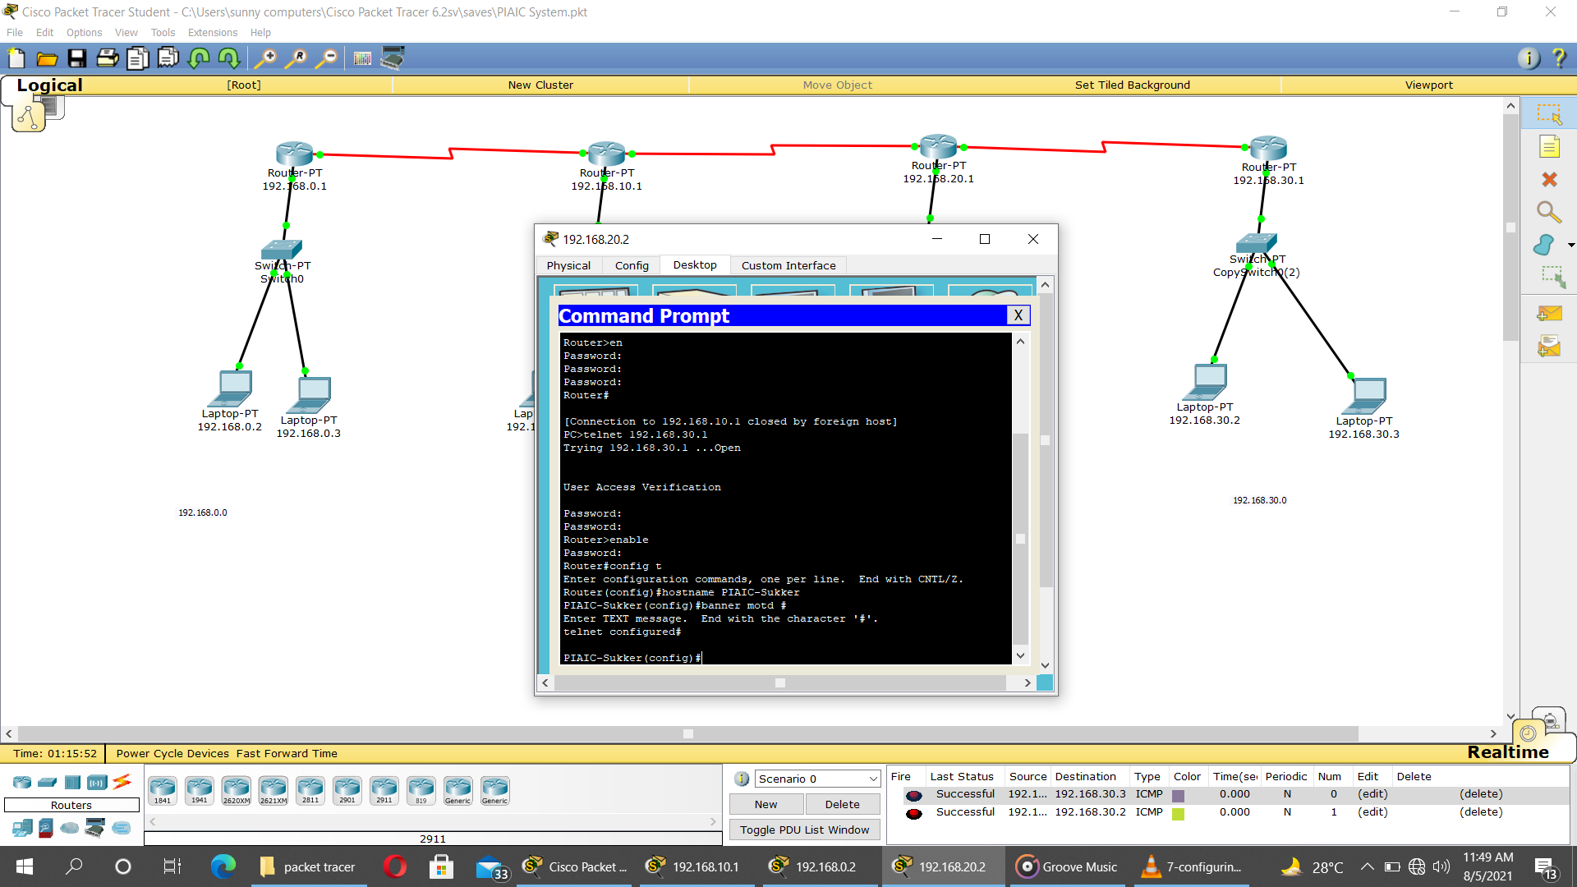**using command prompt of device to access other network device and set hostname and banner.**

**GithubLink of File:**[**https://github.com/Asif26/-Network-Management-and-Security--Assignment-2.git**](https://github.com/Asif26/-Network-Management-and-Security--Assignment-2.git)